**Consider the following case study specification:**

The PizzaHust Ordering System allows the user of a web browser to order pizza for home delivery. To place an order, shopper searches o find items to purchase, adds items one at a time to a shopping cart, and possibly searches again for more items.

When all items have been chosen, the shopper provides a delivery address. If not paying with cash, the shopper also provides credit card information.

The system has an option for shoppers to register with the pizza restaurant. They can then save their name and address information, so that they do not have to enter this information every time that they place an order.

Questions:

1. (1.0 points) Develop a use case diagram, for a use case for placing an order, named PlaceOrder. The use case should show a relationship to two previously specified use cases, IdentifyCustomer, which allows a user to register and login, and PayByCredit which models credit card payments.
2. (1.0 points) By your experience, give the use case specification details for paying by credit card.
3. 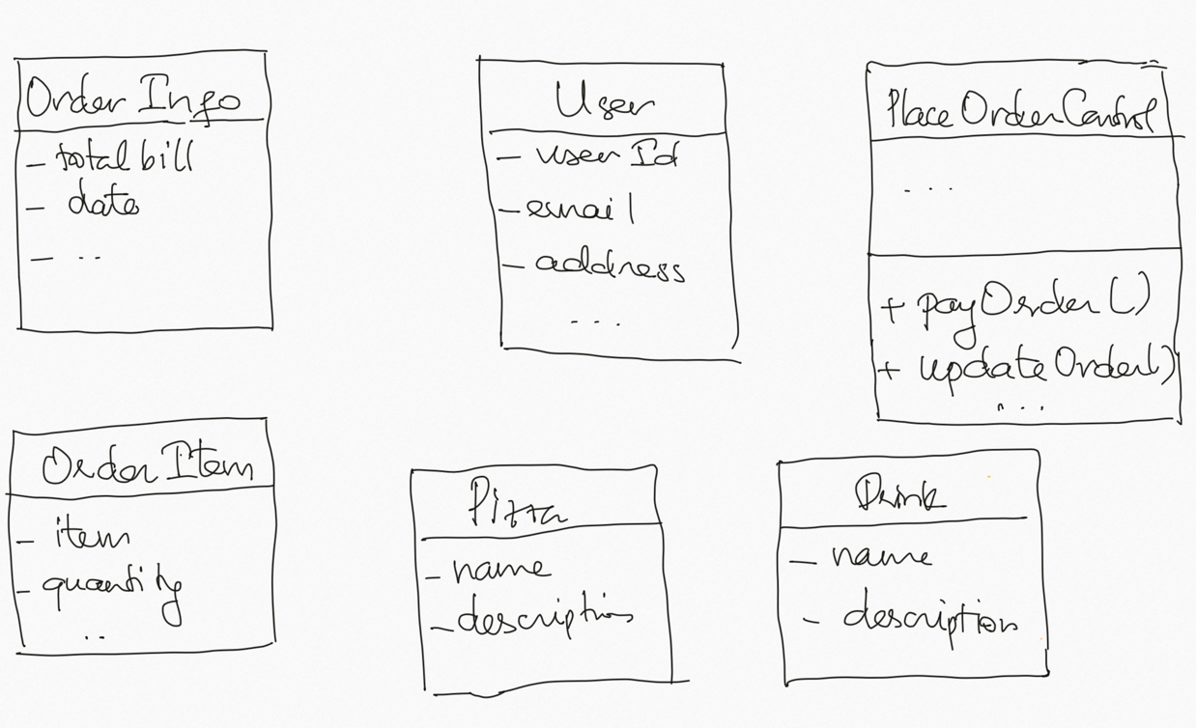(2.0 points) To develop a module for placing an order, the following classes are designed: OrderInfo, OrderItem, Pizza, Drink, User and PlaceOrderControl.

You have to identify the relationship between these classes (adding more classes is considered if necessary).

1. (1.0 points) To perform the payment, the current version of the system considers two methods: by cash and by credit card. Two classes need to be considered: PayByCash and PayByCreditCard. However, in the second release, the development team should also consider other methods for example: pay by momo wallet, pay by ZaloPay etc. Give a solution by a class diagram (with detailed relationships among classes) to resolve this issue.